Java assignment-3
1.Read the age and citizenship status of a person. Determine whether the person is eligible to vote.
Flowchart:
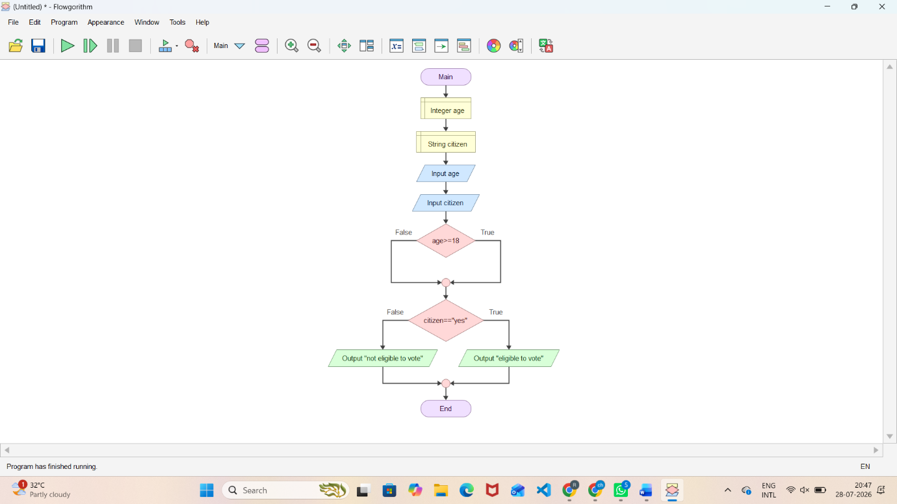
PSEUDO CODE:
START

DECLARE age AS INTEGER
DECLARE citizenship AS STRING

OUTPUT "Enter age:"
INPUT age

OUTPUT "Enter citizenship status (Yes/No):"
INPUT citizenship

IF age >= 18 AND citizenship = "Yes" THEN

OUTPUT "The person is eligible to vote."

ELSE

OUTPUT "The person is not eligible to vote."

END IF

STOP
JAVA CODE:
import java.util.Scanner;

public class Main {
public static void main(String[] args) {

Scanner sc = new Scanner(System.in);

System.out.print("Enter age: ");
int age = sc.nextInt();

System.out.print("Enter citizenship status (yes/no): ");
String citizenship = sc.next();

if (age >= 18 && citizenship.equalsIgnoreCase("yes")) {
System.out.println("Person is eligible to vote");
}
else {
System.out.println("Person is not eligible to vote");
}

sc.close();
}
}
2.Read N daily sales values into an array and display the highest-sales day number and lowest-sales day number.
Flowchart:
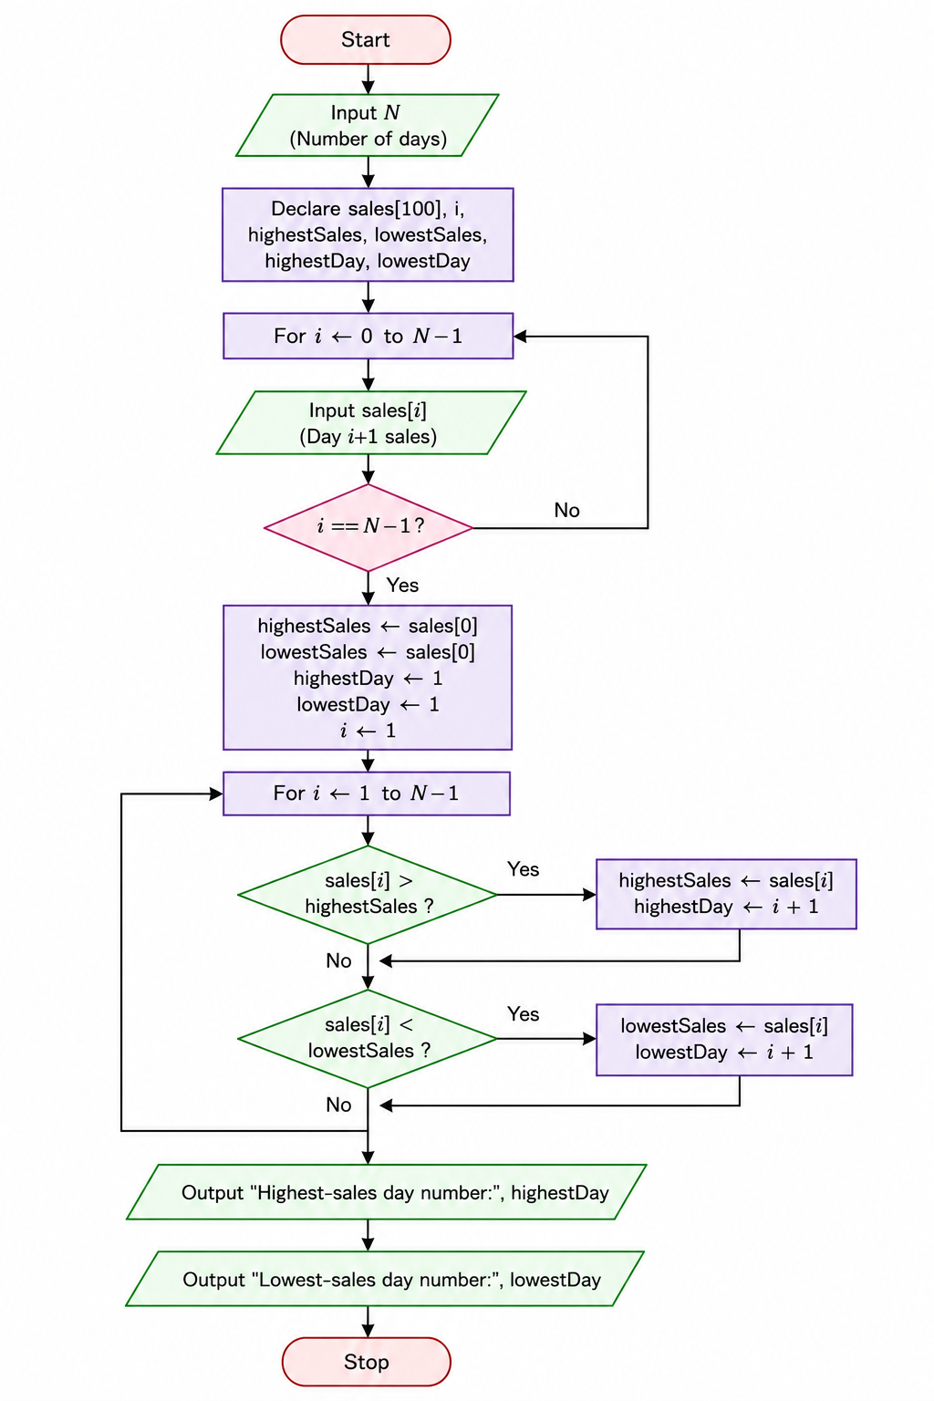
Pseudo code:
START

Read number of days N

Create an array sales[N]

FOR i = 0 to N-1
Read sales[i]
END FOR

Set highest = sales[0]
Set lowest = sales[0]

Set highestDay = 1
Set lowestDay = 1

FOR i = 1 to N-1

IF sales[i] > highest THEN
highest = sales[i]
highestDay = i + 1
END IF

IF sales[i] < lowest THEN
lowest = sales[i]
lowestDay = i + 1
END IF

END FOR

Display "Highest sales day number:", highestDay

Display "Lowest sales day number:", lowestDay

STOP
JAVA CODE:
import java.util.Scanner;

public class Main {
public static void main(String[] args) {

Scanner sc = new Scanner(System.in);

System.out.print("Enter number of days: ");
int N = sc.nextInt();

int sales[] = new int[N];

System.out.println("Enter sales values:");

for (int i = 0; i < N; i++) {
sales[i] = sc.nextInt();
}

int highest = sales[0];
int lowest = sales[0];

int highestDay = 1;
int lowestDay = 1;

for (int i = 1; i < N; i++) {

if (sales[i] > highest) {
highest = sales[i];
highestDay = i + 1;
}

if (sales[i] < lowest) {
lowest = sales[i];
lowestDay = i + 1;
}
}

System.out.println("Highest sales day number: " + highestDay);
System.out.println("Lowest sales day number: " + lowestDay);

sc.close();
}
}

3. Create functions to calculate gross salary and net salary after deductions. Process an array of employee basic salaries.
Flowchart:
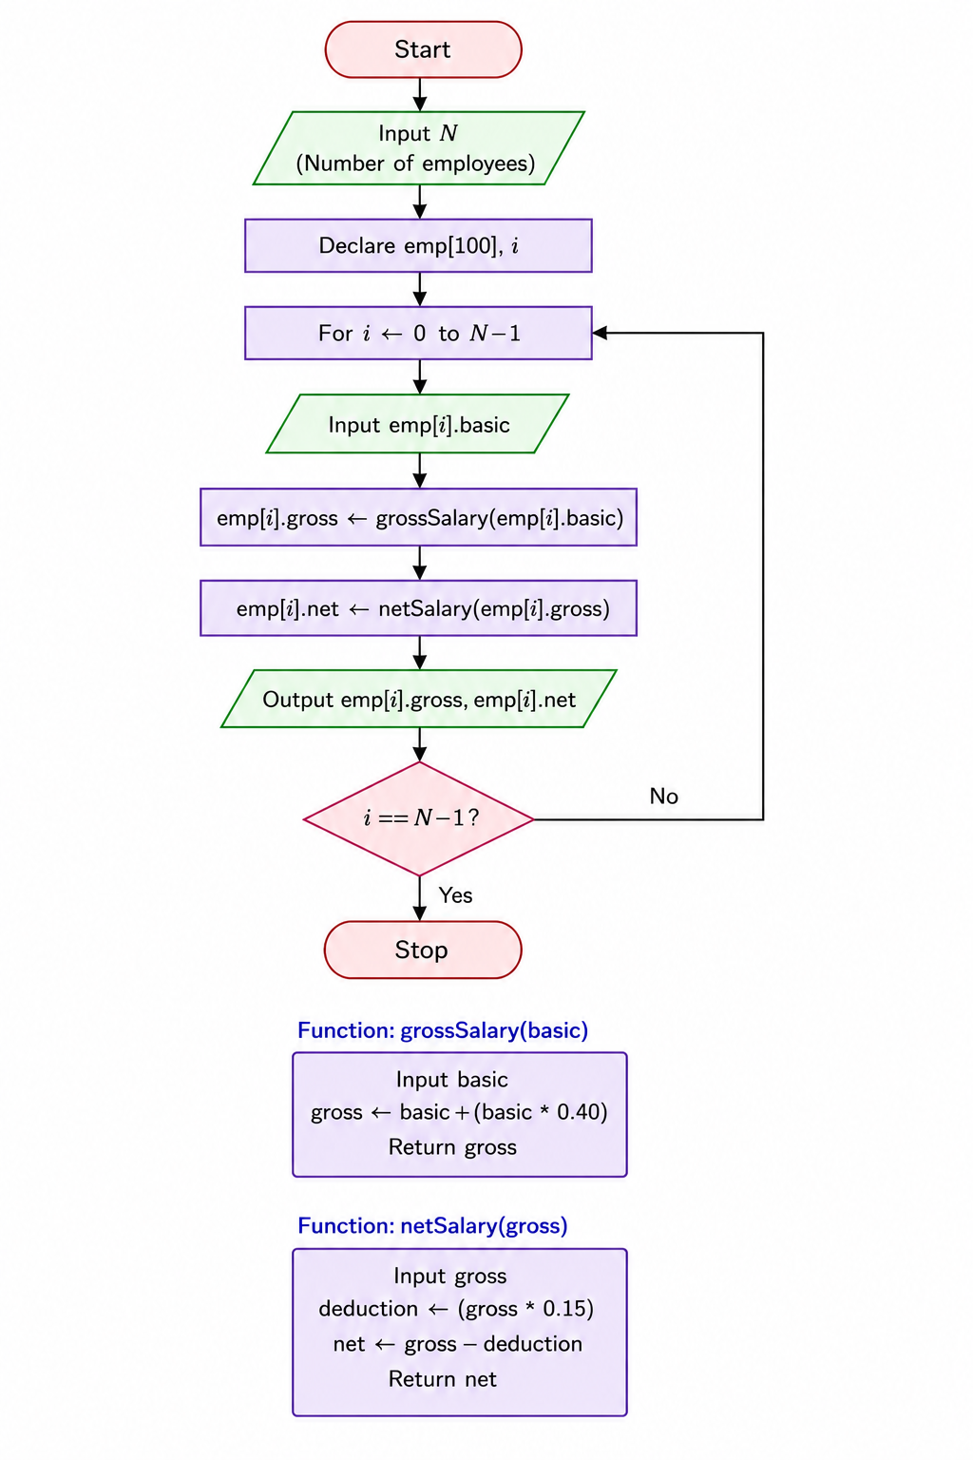
Pseudo code:
START

Read number of employees N

Create an array basicSalary[N]

FOR i = 0 to N-1
Read basicSalary[i]
END FOR

FUNCTION calculateGrossSalary(basic)

Set hra = basic * 0.20
Set da = basic * 0.10

gross = basic + hra + da

RETURN gross

END FUNCTION

FUNCTION calculateNetSalary(gross)

Set deduction = gross * 0.05

net = gross - deduction

RETURN net

END FUNCTION

FOR i = 0 to N-1

grossSalary = calculateGrossSalary(basicSalary[i])

netSalary = calculateNetSalary(grossSalary)

Display "Employee", i+1
Display "Gross Salary:", grossSalary
Display "Net Salary:", netSalary

END FOR

STOP
JAVA CODE:
import java.util.Scanner;

public class Main {

// Function to calculate gross salary
static double calculateGrossSalary(double basic) {
double hra = basic * 0.20;
double da = basic * 0.10;

double gross = basic + hra + da;

return gross;
}

// Function to calculate net salary
static double calculateNetSalary(double gross) {
double deduction = gross * 0.05;

double net = gross - deduction;

return net;
}

public static void main(String[] args) {

Scanner sc = new Scanner(System.in);

System.out.print("Enter number of employees: ");
int N = sc.nextInt();

double basicSalary[] = new double[N];

System.out.println("Enter basic salaries:");

for (int i = 0; i < N; i++) {
basicSalary[i] = sc.nextDouble();
}

for (int i = 0; i < N; i++) {

double grossSalary = calculateGrossSalary(basicSalary[i]);

double netSalary = calculateNetSalary(grossSalary);

System.out.println("Employee " + (i + 1));
System.out.println("Gross Salary: " + grossSalary);
System.out.println("Net Salary: " + netSalary);
}

sc.close();
}
}

